From the salt marshes to circular packaging: Noirmoutier Sea Salt transitions to Sonoco’s paper-based GreenCan®
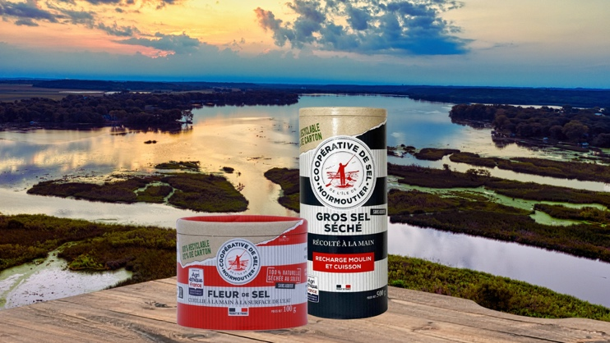
Hockenheim, March 26th 2026 - On the Atlantic coast of France, where sea salt has been harvested by hand for centuries, the Noirmoutier Sea Salt Cooperative is taking a new step to ensure that the values behind its products are reflected all the way to the packaging on the shelf.
The cooperative has begun transitioning its Agri-Éthique labelled sea salt range to Sonoco’s GreenCan®, replacing its previous plastic sprinkler container with a high-paper-content alternative featuring an integrated paper lid. The move reflects the cooperative’s ambition to reduce plastic use while maintaining the protection and quality required for a product as sensitive to humidity as sea salt.
For the cooperative, the decision was about consistency between the origin of the product and the packaging that delivers it to consumers.
“Certified Agri-Éthique, our cooperative is committed to responsibility and coherence in every decision we make,” the cooperative explains. “In anticipation of the upcoming PPWR regulation, we wanted to reduce plastic waste by adopting packaging that is more sustainable and genuinely circular. Sonoco’s GreenCan® met our sustainability requirements and allowed us to implement this transition with a solution aligned with our values and our long-term vision.” Joël Piau, Cooperative Director
“GreenCan® combines high paper content with functional performance for demanding food applications. The packaging contains up to 98% paper and incorporates renewable and recycled fibres, while providing the barrier protection needed to preserve product freshness and quality. For hygroscopic products such as sea salt, this balance between sustainability and protection is critical.” Explains Mr Piau.
Created in 2013, Agri-Éthique is the first French fair-trade label dedicated to supporting farmers through fair prices and long-term partnerships. By adopting a high-fibre packaging solution, the Noirmoutier cooperative is extending this philosophy of responsibility beyond the product itself to the entire value chain.

A wide shift towards fibre-based packaging
The transition reflects a broad transformation underway across the packaging industry. Increasingly, brands are taking a stand, replacing plastic packaging with fibre-based alternatives — a shift often referred to as “paperisation.” The momentum behind this movement is accelerating rapidly. Between 2023 and 2025, product launches using paper-based packaging formats increased by more than 122% according to Mintel, illustrating how quickly brands across food, personal care and household categories are exploring alternatives to plastic packaging.
“Several forces are driving this shift. Consumers have a good perception of paper packaging, especially the younger generations of consumers (GenZ), associating paper packaging with environmental benefits, safety and good value for money. Retailers and brands are getting ready for the Packaging and Packaging Waste Regulation (PPWR), prioritising circular packaging formats. Technological progress and innovations such as Sonoco’s Greencan® are also expanding the possibilities for fibre-based solutions. Advances in packaging design now enable paper formats to protect sensitive products while maintaining

product integrity and shelf appeal.” Explains Seàn Cairns, President of Sonoco Consumer Packaging EMEA/APAC.
“Against this backdrop, the Noirmoutier Cooperative initiative illustrates how heritage food brands can rethink packaging as an integral part of their sustainability strategy — aligning product values, consumer expectations and future regulatory requirements. For Noirmoutier Sea Salt, the transition represents more than a packaging change. It is a way to ensure that a product rooted in one of France’s most iconic coastal landscapes continues to reflect the principles of responsibility and sustainability that have defined it for generations.” Says Mr. Cairns.
Beyond the packaging transition itself, the project highlights the proactive role the Noirmoutier Sea Salt Cooperative continues to play in shaping more responsible food production. Rather than waiting for regulatory change, the cooperative chose to anticipate the evolution of packaging expectations and take concrete steps aligned with its long-standing commitments. Implementing the new packaging required careful evaluation to ensure that sustainability improvements would not compromise the protection of a product as sensitive as sea salt. Through this transition, the cooperative demonstrates that environmental progress can be achieved while maintaining the high quality standards expected from a premium, origin-based product.
For the Noirmoutier Sea Salt Cooperative, this transition represents another step in a long tradition of balancing heritage with innovation — ensuring that a product deeply rooted in local ecosystems and artisanal know-how continues to evolve in a way that respects both the environment and future generations.
About Sonoco
Founded in 1899, Sonoco (NYSE: SON) is a global leader in value-added, sustainable metal and fibre consumer and industrial packaging. The Company is now a multi-billion-dollar enterprise with approximately 22,500 employees working in 265 operations in 40 countries, serving some of the world’s best-known brands. Guided by our purpose of Better Packaging. Better Life., we strive to foster a culture of innovation, collaboration and excellence to provide solutions that better serve all our stakeholders and support a more sustainable future. Sonoco was proudly named one of America’s Most Responsible Companies by Newsweek. For more information on the Company, visit our website at www.sonoco.com .
Media contacts
Sonoco Consumer Packaging EMEA:
Isabelle Le Graët – Senior Marketing Manager Isabelle.legraet@sonoco.com

